98th Meeting of the American Astronomical Society
--PRESS RELEASE--

Contact: Steve Maran (GSFC Media Relations; hrsmaran@eclair.gsfc.nasa.gov)

FOR RELEASE: 9:00 a.m. PST, June 5, 2001

ASTRONOMERS CONSTRUCT THE INFRARED ATLAS OF LARGE GALAXIES

Today astronomers presented the first results of the Infrared Large Galaxy Atlas at the 198th meeting of the American Astronomical Society in Pasadena, California. Thomas Jarrett, Schuyler Van Dyk and Thomas Chester, at the California Institute of Technology, are constructing the image atlas from the Two Micron All Sky Survey (2MASS). The digital atlas will be comprised of the largest galaxies in the local Universe, including the Messier objects (see the photo of M51 below), with angular resolution that resolves the most important structures in the nearby galaxies.
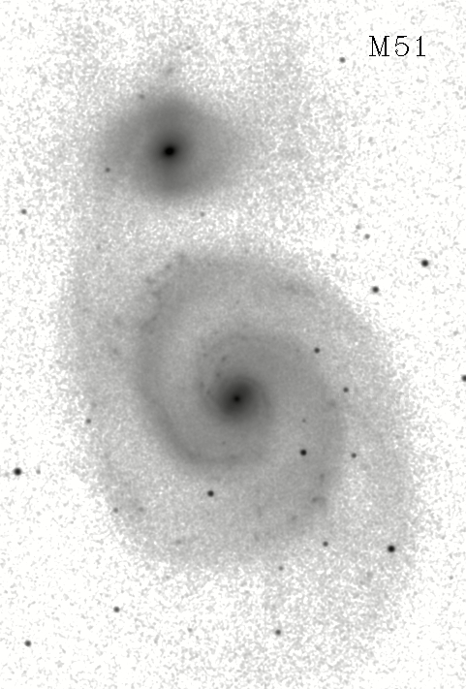
“Nearby galaxies represent a unique laboratory set for detailed study of the largest objects in the Universe. The Atlas provides the necessary sensitivity and angular resolution to examine the diverse stellar populations, large-scale structures such as spirals, bulges, warps and bars, star formation regions and evolution of galaxies,” explains Thomas Jarrett, who is leading the effort. “This image atlas represents the first uniform, all sky, view of galaxies as seen in the near-infrared—a wavelength window that is most sensitive to the dominant mass component of galaxies.”

The 2MASS survey, a collaborative effort between the University of Massachusetts and Caltech’s Infrared Processing and Analysis Center, imaged the entire sky in the near-
infrared 1-2.2 μm window using ground-based telescopes in Arizona (northern hemisphere) and Chile (southern hemisphere). The survey was optimally designed to detect and measure
the brightness of stars and galaxies smaller than ~1-2′ in angular size. Galaxies larger than this size were truncated, and hence were not optimally catalogued by 2MASS, including most nearby galaxies (D < 50 million light years) and Messier objects. It is possible, however, to reconstruct the largest galaxies in full measure by using pieces of the 2MASS imaging data set.

The Large Galaxy Atlas will consist of galaxies ranging in size from 2 to 30′, assembled in two science products: J (1.1 μm), H (1.6 μm) and K_{s} (2.2 μm) 3-band image atlas and a tabular catalog. The images will have a typical angular resolution of ~2 to 3″ and the catalogue will include flux, size and morphology information. At the completion of the 2MASS survey, the atlas will be fully available to the public and can be accessed through the NASA Extragalactic Database (NED).

The Large Galaxy Atlas will represent a valuable asset to the professional and amateur astronomical communities. The near-infrared forms a natural, complementary, bridge between the well-studied optical wavelengths (e.g., POSS and SDSS) and the longer (e.g., IRAS, ISO, NVSS, FIRST) wavelengths. The near-infrared is most sensitive to the older stellar populations—the dominant mass component in most galaxies. Hence, the Large Galaxy Atlas is an ideal data set to combine with imaging data at other wavelengths. It provides a clear contrast between the underlying mass component and, for example, star formation regions as seen in the optical or mid-infrared bands. In addition, the atlas will function as an astrometric “finding” chart/map for both professionals and amateurs searching for supernovae in galaxies.

As part of NASA’s Origins Program, 2MASS is funded by NASA’s Office of Space Science and the National Science Foundation. Results from 2MASS will benefit future Origins missions, including the Space Infrared Telescope Facility (SIRTF) and the Next Generation Space Telescope (NGST). JPL manages the program for NASA’s Office of Space Science, Washington, DC. JPL and IPAC are a division of the California Institute of Technology, Pasadena, CA.

Additional 2MASS information and images are available at the following websites:
(point to jarrett LGA page)
http://www.ipac.caltech.edu/2mass
http://pegasus.phast.umass.edu

For more information:
Dr. Thomas Jarrett (jarrett@ipac.caltech.edu)

CAPTION: The Whirlpool Galaxy (M51) as seen in the three 2MASS near-infrared J (1.2 μm) bands. The Whirlpool, and its small companion galaxy, are 33 million light years from the Sun and are located within the Canes Venatici (CVn) constellation. The image was re-constructed from pieces of the 2MASS image data set. The field is view is 12′. The angular resolution is ~3″, corresponding to a physical size of ~500 light years for structure in M51. Photo credit: Dr. T.H. Jarrett.

Editors: This photograph (and other samples) can be obtained over the Internet via
http: (jarrett website). Images include both color and B&W (positive) versions.
#####

